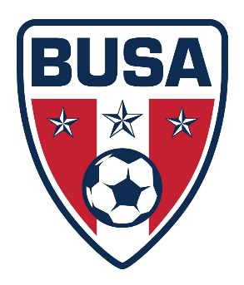
BUSA RULES OF PLAY
U13-U18 AGES
- All FIFA Rules apply unless altered in these rules.
- HOME TEAM WEARS WHITE or light color jerseys.
- Goalkeeper Punting is allowed. *revised 8/25/2024
- Keeper must wear different color shirt or pinnie from team colors.
- Offside will be called, results in Indirect Kick from spot
- There is NO SLIDE TACKLING PERMITTED. (Contact with opponent is a tackle, no contact slide is permitted)
- Substitutions may occur for either team at stoppages of play
- Free kicks are either indirect or direct, per FIFA rules
- All penalty kick are taken 12 yards from endline.
- Games are:
  - U13/14 – 35 minute halves, with 5 minute halftime break.
  - U15/16 – 40 minute halves with 10 minute halftime break
  - U17/18 – 45 minute halves with 10 minute halftime break
- Parents must sit opposite their team on their half of the field. No sitting on opponent’s side. No parents shall be on the sideline with coaches and players.
- No persons shall be at the end line, near the goal area. May be within 5 yards of corner only. Photographers may roam into all areas, but are not permitted to speak at any time during photo taking. Not permitted on sideling of coaches and players.
- No metal jewelry may be worn, no earrings, no exception Official Game Rosters will be required to present to the referee at pregame check in. Paper or phone is ok. Only coaches on roster are permitted to be on sideline with team. Only rostered persons are permitted in bench area.
- Casts or braces must be wrapped in foam, bubble, or acceptable wrap completely and covering all hard areas of cast. Referee is the sole decision on cast being worn in games.
- ABSOLUTELY NO YELLING OR CONFRONTING A REFEREE IS PERMITTED. There will be no tolerance for inappropriate sideline behavior from coaches, players, or parents.

